https://play.google.com/store/books/details?id=OohDAQAAMAAJ&rdid=book-OohDAQAAMAAJ&rdot=1

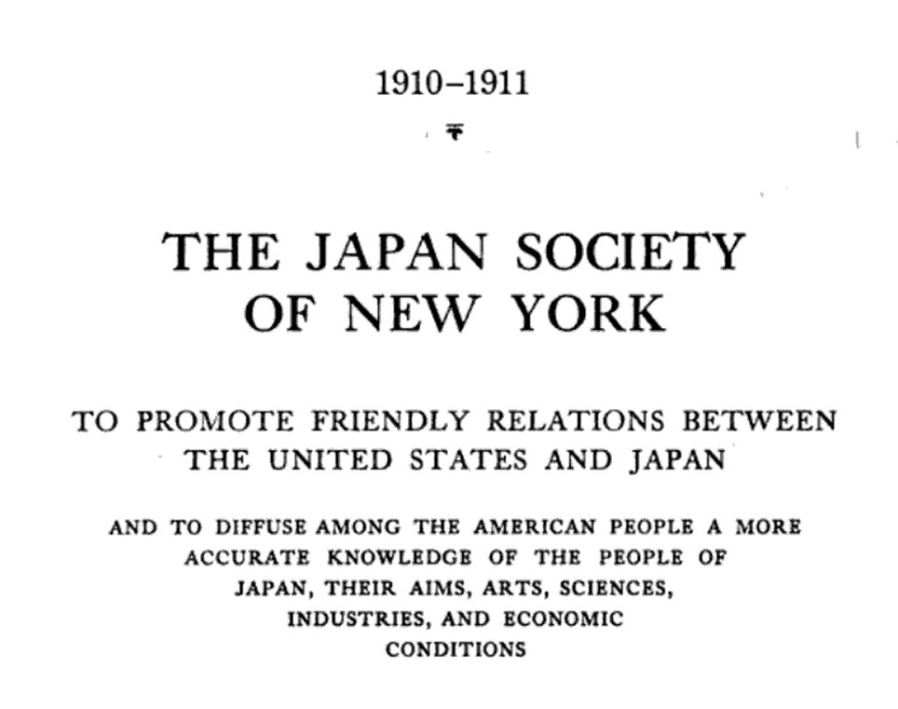

1910 New York
The Japan Society of New York, To Promote Friendly Relations Between the United States and Japan, and to Diffuse Among the American People a More Accurate Knowledge of the People of Japan, Their Aims, Arts, Sciences, Industries, and Economic Conditions – Japan Society (New York, N.Y.)

Statement at the beginning of the publication:
A land where . . . “Everybody greets everybody with happy looks and pleasant words, faces are always smiling, the commonest incidents of every-day life are transﬁgured by a courtesy at once so artless and so faultless that it appears to spring directly from the heart without any teaching . . . the temple courts are the playgrounds for children. . . . Cruelty, even to animals, is unknown; one sees farmers coming to town trudging patiently beside their horses or oxen, aiding their dumb companions to bear the burden, and using no whips or goads.” There are "districts where no case of theft had occurred for hundreds of years—where the . . . prisons . . . remained empty and useless. . . . Where you discover no harshness, no rude ness, no dishonesty, no breaking of laws and learn that this social condition has been the same for centuries, you believe that you have entered into the domain of a morally superior humanity.” LAFCADIO HEARN, Japan.

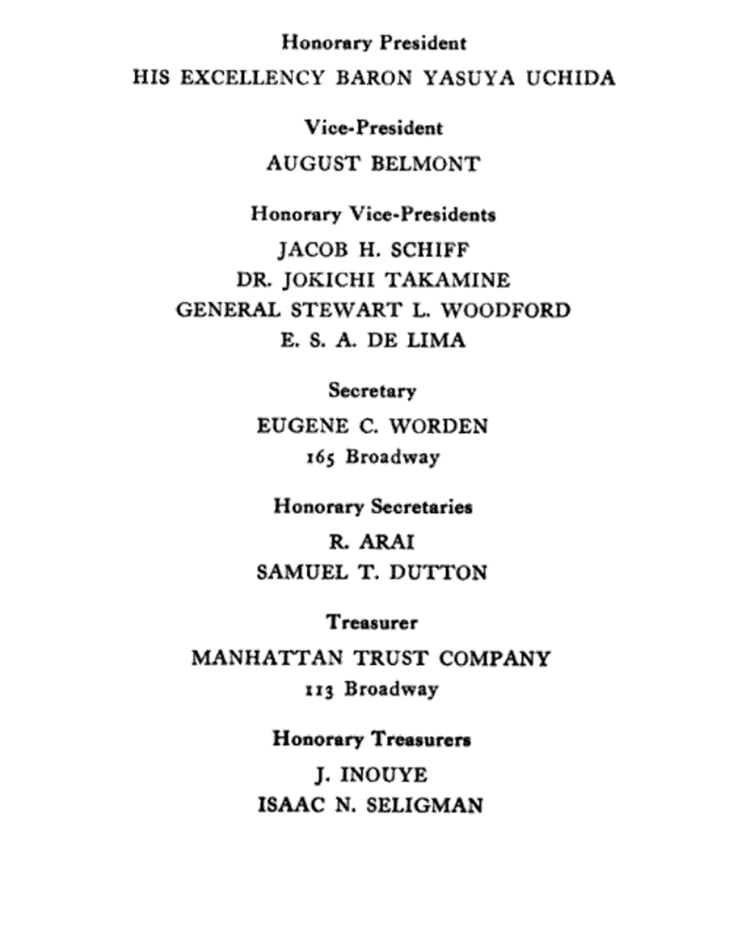

OFFICERS 1910 —1911
President LINDSAY RUSSELL
Honorary President HIS EXCELLENCY BARON YASUYA UCHIDA
Vice-President AUGUST BELMONT
Honorary Vice-Presidents:
JACOB H. SCHIFF
DR. JOKICHI TAKAMINE
GENERAL STEWART L. WOODFORD
E. S. A. DE LIMA

Secretary EUGENE C. WORDEN 165 Broadway Honorary
Secretaries:
R. ARAI
SAMUEL T. DUTTON
Treasurer MANHATTAN TRUST COMPANY:
13 Broadway
Honorary Treasurers:
J. INOUYE
ISAAC N. SELIGMAN

